**Counterfeiting Detection System: A Solution to Combat Product Counterfeiting**

**Archit Rajesh Shrivastava**

*Department of Computer Science*

KIET Group of Institutions, Delhi-NCR, Ghaziabad

Uttar Pradesh, India

[architbiz1203@gmail.com](mailto:architbiz1203@gmail.com)

**Ankita Jain**

*Department of Computer Science*

KIET Group of Institutions, Delhi-NCR, Ghaziabad

Uttar Pradesh, India

[ankitajain632003@gmail.com](mailto:ankitajain632003@gmail.com)

**Bhoomika Saxena**

*Department of Computer Science*

KIET Group of Institutions, Delhi-NCR, Ghaziabad

Uttar Pradesh, India

[bhoomika.work12@gmail.com](mailto:bhoomika.work12@gmail.com)

**Harsh Khatter**

*Department of Computer Science*

KIET Group of Institutions, Delhi-NCR, Ghaziabad

Uttar Pradesh, India

[harsh.khatter@kiet.edu](mailto:harsh.khatter@kiet.edu)

***Abstract —* Counterfeiting is a growing problem impacting the global marketplace, especially burgeoning economies like India. It hampers economic growth and leaves consumers struggling to differentiate between genuine products and fakes. In response, this research paper introduces an innovative solution - the "Counterfeit Detection System." This system employs QR codes linked to a manufacturer's database, offering a reliable tool for real-time product authentication. When a QR code is scanned, the system validates the product's authenticity, ensuring consumers are purchasing genuine items. The system aims to protect consumers and manufacturers, enhance supply chain transparency, and fortify brand trust. While the initial focus is on branded clothing, the principles underpinning the system can be applied across various industries. In a wider perspective, this research emphasizes the significance of innovative, tech-based solutions in safeguarding consumers and businesses from the far-reaching negative effects of counterfeit products. As we navigate the era of digital consumption, resources like the Counterfeit Detection System become increasingly vital in upholding the integrity of the global market. This study strives to spotlight the potential of such technology in combating the counterfeit market, ultimately aiding in establishing a more secure and reliable shopping environment. This paper provides guidance for manufacturers, retailers, consumers, and policymakers interested in comprehending and tackling the intricate problem of counterfeiting.**

***Keywords— Counterfeiting, Supply chain transparency, QR Code, Digital consumption, Global Marketplace.***

**1. INTRODUCTION**

The Counterfeit Detection System is a vital web application designed to combat the pervasive issue of counterfeit clothing products. In a world where consumers often find themselves in a precarious position—uncertain whether the product they intend to purchase is genuine or a deceptive knockoff—this innovative solution emerges as a safeguard against fraud. The ramifications of unknowingly buying counterfeit goods are profound, leading to financial losses for consumers and tarnishing the reputation of authentic brands. For companies, the consequences include lost sales due to undercutting prices, erosion of brand integrity, strained relationships with business partners, and the need to allocate resources to combat counterfeiting.

Recognizing the urgency of this problem, the Counterfeit Detection System steps in to assist users in navigating this treacherous terrain. Its mission is clear: to empower consumers with the tools needed to make informed purchasing decisions and to eradicate counterfeit products from the marketplace. At its core, this web application leverages the innovative concept of QR code scanning, offering a seamless and efficient means of verifying product authenticity during the purchasing process. [1]

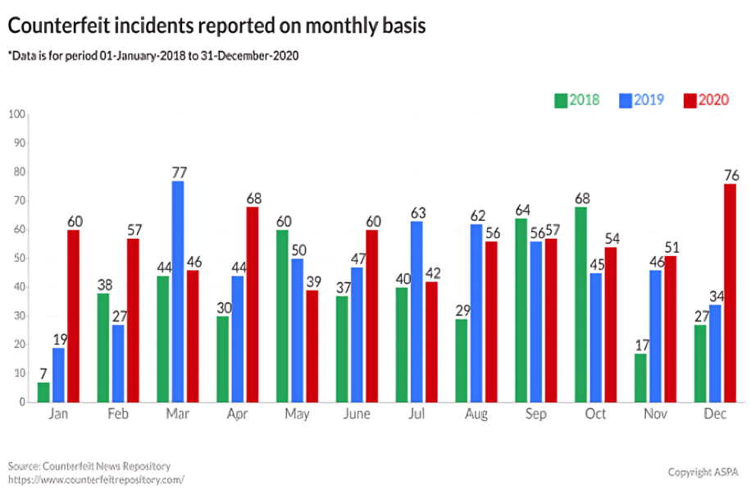

**Figure 1. Counterfeit incidents reported on monthly basis [2]**

The Counterfeit Detection System is designed with a multi-faceted technological foundation, incorporating the prowess of Machine Learning, Front-End and Back-End web development, and a robust database. Machine Learning, a subset of Artificial Intelligence, plays a pivotal role in the system, enabling automated processes and decision-making without the need for manual human intervention.

On the web development front, React is harnessed for the Front-End, providing an intuitive and user-friendly interface that facilitates QR code scanning and the retrieval of product details. Meanwhile, Django powers the Back-End, managing the database, authentication, and the seamless flow of information.

The system takes an active approach towards eradicating counterfeiting by embedding QR code technology into its operations. This integration ensures each product can be traced back to its origin, affirming its legitimacy. The application of QR codes not only increases the transparency of the product's journey from production to sale but also facilitates real-time updates about the product's status.

An integral aspect of this methodology is the enablement of consumers. By providing comprehensive product information accessible via QR codes, the system allows consumers to independently verify the authenticity of their purchases. This strategy not only deters counterfeiters but also cultivates consumer confidence in the brands they opt for [3]. The Counterfeit Detection System also incorporates a robust framework for handling infringements. In the event a retailer is discovered to be selling counterfeit products, an automatic alert is activated, prompting a thorough investigation. This robust preventive action is a crucial component of the system's strategy to combat counterfeiting [10].

In essence, the Counterfeit Detection System is not merely a web application; it is a beacon of hope for consumers and brands alike, illuminating a path toward a counterfeit-free shopping experience. It embodies the spirit of technological innovation harnessed for the greater good, safeguarding trust in commerce and ensuring that every purchase is a genuine one.

**2. LITERATURE REVIEW**

A thorough study of related research papers was carried out to better understand the topic.

Wasnik et al. [9] present an in-depth analysis of how blockchain technology can be leveraged to enhance supply chain transparency and security. This paper thoroughly explains the decentralized nature of blockchain technology, highlighting its ability to prevent unauthorized data modifications. In comparison to traditional methods like RFID tags and QR codes, blockchain technology is proposed as a more effective solution due to its inherent traceability features. The authors argue that blockchain technology can significantly mitigate the adverse impacts of counterfeit products on the economy and consumer safety by enhancing the traceability and security of supply chains.

Agrawal et al. [13] delve into a unique approach towards bolstering product authentication and traceability in the textile and clothing industry. Their research introduces a secured tag system based on particle randomness. This system uses particles as unique identifiers applied onto textile surfaces, providing a solution that is resistant to cloning. This innovative approach builds upon the advantages of barcodes, a cost-effective and efficient means of product tracking, and introduces an extra layer of security through the particle-based secured tag. The authors convincingly argue that this system can significantly mitigate the risks of counterfeiting in industries that are particularly vulnerable to such practices.

In the research paper by Sathyanarayana et al. [14] presents a novel network-based approach to counterfeit detection. By monitoring the network traffic of a device, the authors propose a cost-effective, fast, and non-destructive means to identify counterfeit devices. This approach requires no specialized hardware or complex setups, making it highly accessible. The authors demonstrate the effectiveness of this technique using field-programmable gate arrays (FPGAs) and real systems with different processors, achieving recall values of up to 78.7% in detecting counterfeit components. This research suggests that the network-based approach can have broad applicability and offer an attractive solution for companies seeking effective measures against counterfeiting.

In the research paper by Daoud et al. [7], the authors emphasize the importance of AI-based technology in counterfeit product detection. They propose a system that combines image and text recognition, allowing end consumers to capture images of product packaging and send them for verification. This approach empowers consumers to contribute to the fight against product piracy and underscores the role of user involvement in detection processes. The authors argue that AI technology can significantly enhance detection capabilities and improve the efficiency and effectiveness of counterfeit detection.

Yoon et al. [8] discuss the application of functional materials for preventing and detecting counterfeiting in their paper. They highlight the growing need for innovative anti-counterfeiting materials and systems due to the rise of sophisticated counterfeit products. The paper focuses on colorimetric and fluorometric methods, organic electronics, and molecular imaging techniques. The authors explore materials like polydiacetylenes (PDAs), a type of conjugated polymer, photochromic compounds, structurally colored material, and paper-based reactive patterns. They argue that such functional materials, with their unique chemical, physical, optical, and electrical properties, hold promise for the development of more secure and reliable anti-counterfeiting systems.

**2.1. REASONS TO WORK**

1. **Economic Impact**: Counterfeiting in the clothing industry leads to significant economic losses for both legitimate brands and the overall economy. It results in reduced sales, profit margins, and market share for genuine clothing manufacturers. Moreover, counterfeit products are often sold at lower prices, negatively affecting the pricing structure and competitiveness of genuine brands.
2. **Brand Reputation**: Counterfeit clothing products can harm the reputation and image of legitimate brands. Inferior quality and poor craftsmanship associated with counterfeit goods can lead to customer dissatisfaction and loss of trust in the genuine brand. This can have long-term consequences, affecting customer loyalty and brand loyalty [11].
3. **Consumer Safety**: Counterfeit clothing items may not undergo proper quality control measures, resulting in substandard materials, hazardous dyes, and poor manufacturing practices. This poses a risk to consumer safety and health. For example, counterfeit clothing items may contain harmful substances or lack necessary safety features like fire-retardant properties.
4. **Intellectual Property Rights**: Counterfeiting involves the unauthorized use of trademarks, logos, and designs of genuine clothing brands. This infringes upon the intellectual property rights of legitimate manufacturers. Protecting intellectual property rights is crucial for fostering innovation and encouraging investment in the clothing industry [12].
5. **Employment and Industry Sustainability**: Counterfeiting undermines the growth and sustainability of the legitimate clothing industry. It leads to job losses and hampers economic development, particularly in regions where the clothing industry plays a significant role. Detecting and combating counterfeiting can help protect legitimate businesses and preserve employment opportunities [14].
6. **Quality Control**: Counterfeit clothing products often lack the quality standards and durability of genuine brands. By detecting counterfeits, consumers can make informed choices and have confidence in the authenticity and quality of the clothing they purchase. This promotes consumer satisfaction and ensures that they get value for their money.
7. **Fair Competition**: Counterfeit products create an unfair competitive environment for genuine clothing manufacturers. Illegitimate businesses that produce counterfeit goods can undercut prices and gain an unfair advantage over legitimate brands. Detecting and preventing counterfeiting helps maintain fair competition and a level playing field for all industry players.

**2.2. EXISTING PROBLEM**

1. **Global Nature**: Counterfeiting in the clothing industry is a global problem, with counterfeit products being manufactured and distributed across different countries. This makes it challenging to enforce anti-counterfeiting measures and coordinate efforts between various jurisdictions. [4]
2. **Complex Supply Chains**: The clothing industry has complex and extensive supply chains, involving multiple stakeholders such as manufacturers, suppliers, distributors, and retailers. Counterfeit products can infiltrate these supply chains at various stages, making it difficult to trace the source and identify the responsible parties. [5]
3. **Consumer Demand**: The demand for counterfeit clothing products is driven by consumers who seek inexpensive alternatives to high-end fashion brands. The lack of awareness and education about the consequences of purchasing counterfeit goods contributes to the perpetuation of the problem. Addressing consumer demand and changing consumer attitudes is crucial in combating counterfeiting in the clothing industry. [6]
4. **Counterfeit Packaging and Labeling**: Counterfeiters often replicate packaging materials, labels, and tags to make their products appear authentic. This makes it difficult for consumers and even retailers to distinguish between genuine and counterfeit clothing items. Improved packaging and labeling techniques, along with effective detection methods, are needed to combat this problem.
5. **Inadequate Collaboration**: Effective counterfeiting detection and prevention require collaboration and information sharing among various stakeholders, including brands, law enforcement agencies, customs authorities, and industry associations. Insufficient collaboration and communication can hinder the timely exchange of intelligence and hinder efforts to combat counterfeiting effectively.
6. **Cost and Resources**: Implementing robust counterfeiting detection systems requires significant investments in technology, training, and infrastructure. Limited resources can pose challenges in developing and maintaining effective detection systems, especially for small businesses or developing economies.

**2.3. OBJECTIVES**

The main objectives of a Counterfeiting Detection System include:

* **Identification of Counterfeit Products**: The primary objective is to identify and distinguish counterfeit products from genuine ones in order to protect consumers from purchasing fake or substandard items.
* **Consumer Protection**: To safeguard consumers from financial losses and health risks associated with counterfeit products, ensuring that they can make informed purchasing decisions.
* **Brand Protection**: Protecting the reputation and integrity of legitimate brands by reducing the circulation of counterfeit goods that can harm their image and market position.
* **Reduction of Illegal Trade**: Combating and reducing the illegal trade of counterfeit goods that can have adverse economic, social, and legal implications.
* **Marketplace Trust**: To establish and maintain trust in the marketplace, ensuring that consumers have confidence in the authenticity of products they purchase.
* **Preventing Health and Safety Risks**: Detecting counterfeit products that might pose health and safety risks to consumers, such as counterfeit medicines, food, or electronics.
* **Minimizing Revenue Loss**: Preventing revenue losses for businesses due to counterfeit competition and price undercutting.
* **Supply Chain Integrity**: Ensuring the authenticity of products within the supply chain, protecting against the infiltration of counterfeit items.

**3. EXISTING METHODOLOGY**

Some of the existing methodology for the counterfeiting detection includes [7]-

* **Barcodes**: Implementing traditional barcodes for product identification and authentication, which are less versatile and less secure compared to QR codes.



**Figure 2. Barcode**

* **Holographic Seals**: Using holographic seals on products as a security measure, but these can still be copied by skilled counterfeiters.
* **Radio-Frequency Identification (RFID)**: Embedding RFID chips in products for tracking and authentication, but this can be costlier and may require additional infrastructure.

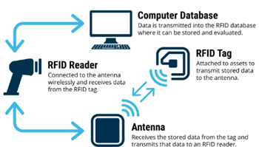

**Figure 3. Radio-Frequency Identification [15]**

* **Blockchain without QR Codes**: Relying on blockchain technology for product traceability and authenticity verification without the user-friendly aspect of QR codes.
* **Colorimetric and fluorometric approaches:** It offers simplicity, cost-effectiveness, sensitivity, quantitative analysis, and applicability in diverse concentrations, ensuring reliable counterfeit detection
* **Physical Authentication Marks**: Using physical authentication marks like embossed logos or seals on products, which may not provide real-time validation.
* **Consumer Feedback Alone**: Relying solely on consumer reviews and feedback as a means of counterfeit detection without a systematic technological verification system.
* **Magnetic Stripes**: Implementing magnetic stripes on products for authentication, which can be less secure and easier to replicate than digital methods like QR codes.
* **Offline Verification Centers**: Establishing physical verification centers that consumers need to visit in person for product authentication, which is less convenient and accessible.
* **Security Labels**: Using security labels or stickers on products for authentication, which may not provide the same level of convenience as QR code scanning.



Figure 4. Existing Counterfeiting Methodologies

### **4. PROPOSED METHODOLOGY**

In this “COUNTERFEIT DETECTION SYSTEM”, we will be having a QR code associated with the unique ID of product where while scanning, it will show various details about the company and the all the necessary information like whether the product is sold before or not, manufacturing place, manufacturer name, etc.

The proposed Counterfeit Detection System presents a holistic strategy for addressing counterfeit products by utilizing QR code technology.

In the initial stages, the system requires the precise input of product details into the QR code system. This includes crucial information such as the company name, product specifications, available sizes, color variations, and pricing. This detailed data aims to empower consumers, helping them make well-informed purchasing decisions and choose the right products.

Following this, the distribution process begins as companies sell their products to retailers, each item tagged with a unique product ID for easy tracking. Retailers then sell these products to consumers at prices determined by the company, promoting transparency and accountability in sales.

When consumers buy products, they can scan the QR codes to access real-time product information. If an invalid QR code is detected, an automatic alert notifies the company, leading to investigations and actions against non-compliant retailers. On the other hand, valid QR code scans allow consumers to leave reviews, encouraging consumer engagement and deterring counterfeit product reproduction.

Overall, this robust system, supported by QR code technology, serves as a strong defense mechanism, ensuring product authenticity and fostering consumer trust in reputable brands for a safer and more transparent shopping experience.

Here's how the Counterfeit Detection System works:

* **QR Code Scanning**: As consumers prepare to make a purchase, they encounter a crucial checkpoint—the QR code affixed to the product. With a quick scan using their mobile devices, they initiate the process.
* **Validation and Product Details:** The system springs into action, rigorously validating the QR code's authenticity. If the QR code checks out as genuine, users are seamlessly redirected to the official website of the brand, where a wealth of essential product details awaits. These details include a stamp of authenticity from the brand, the original price of the product, its current sold status, and insights into its supply chain journey.

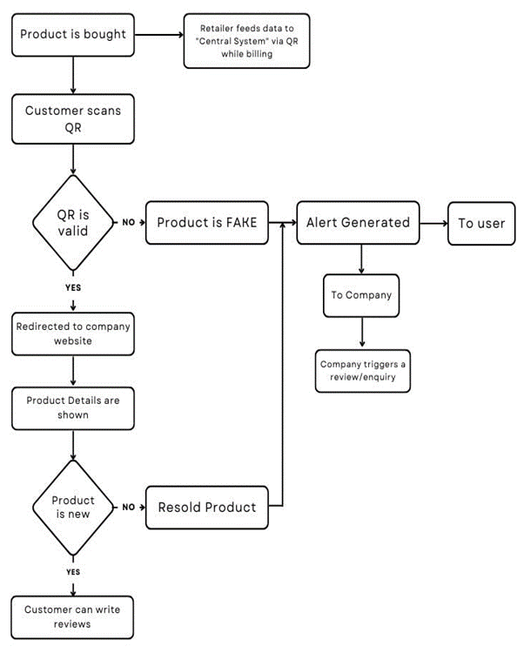

**Figure 5. Flowchart of the Proposed Counterfeiting Detection System**



**Figure 7. Redirect Page**

* **Informed Decision-Making**: Armed with this valuable information, consumers are empowered to make informed decisions about their purchase. If the product is confirmed as new and unsold, they can proceed with confidence, knowing they are acquiring an authentic item. On the other hand, if the QR code raises any doubts or the product has been resold, the system triggers an alert, both to the user and the concerned brand. This proactive approach serves as a powerful deterrent to counterfeit activity.

**Company End:**



**Figure 9. Login Page**

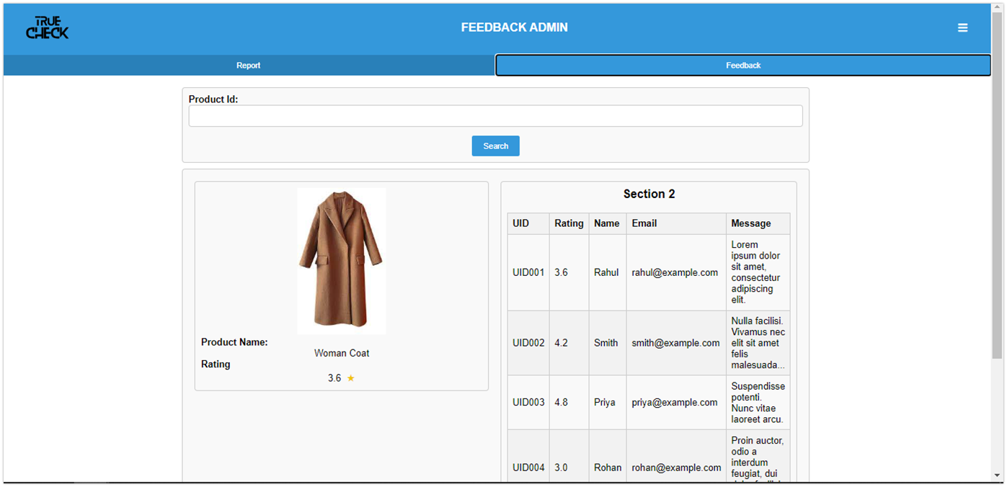

**Figure 17. Feedback Admin Dashboard (Feedback Panel)**

**5. DATASETS AND INPUTS**

Throughout the entire process, we're using our carefully created dataset.

**Phase 1:**

Inputs: Information about the product (company name, brand name, characteristics, size, color, price, etc.)

Output: Encoding of the product details into a QR code

**Phase 2:**

Inputs: Product with a unique product ID

Output: Sale of the product to the retailer.

**Phase 3:**

Inputs: Consumer scanning the QR code

Output: Display of product details to the consumer.

**Phase 4:**

Inputs: Invalid QR code or product status indicating it has been sold before

Output: Alert generation to the company, retailer inquiry initiated, potential actions against the retailer.

**Phase 5:**

Inputs: Valid QR code

Output: Consumer ability to write product reviews, check against replication of branded products

**6. CONCLUSION**

In conclusion, the proposed Counterfeit Detection System, leveraging QR code technology, provides a robust safeguard against counterfeit products. The system's methodology incorporates comprehensive product data into QR codes, assigns unique identifiers to each product for distribution to retailers, and facilitates consumer verification of product authenticity. The applications of this system are broad-ranging, extending to sectors such as pharmaceuticals, automotive components, electronics, and luxury goods, among others. Anticipated enhancements for the future include the integration of machine learning and Internet of Things (IoT) technologies. These additions aim to boost authentication efficiency, facilitate real-time tracking, and optimize overall performance. This will not only enhance the system's functionality but also its adaptability to evolving counterfeit tactics. This system stands out from existing solutions due to its real-time authentication, transparency, and consumer engagement. In essence, it provides an effective, scalable, and tech-driven solution to counterfeiting, *revolutionizing product authenticity and consumer trust in the digital age.

**REFERENCES**

1. S. Tiwari, "An Introduction to QR Code Technology," 2016 International Conference on Information Technology (ICIT), Bhubaneswar, India, 2016, pp. 39-44, doi: 10.1109/ICIT.2016.021.
2. Patel, A. K., & Singh, A. (2018). "A study on counterfeit brands, consumer attitude and initiatives to stop counterfeiting in india." Ad Valorem - Journal of Law, 5(II), April - June 2018, ISSN: 2348-5485
3. Picard, J., Landry, P., & Bolay, M. (2021). "Counterfeit detection with QR codes." In Proceedings of the 21st ACM Symposium on Document Engineering, Association for Computing Machinery, New York, NY, USA, Article 16, 1–4. <https://doi.org/10.1145/3469096.3474924>.
4. Pio, Luigi & Cavaliere, Luigi Pio Leonardo. “The Impact Of Brand Counterfeiting On Consumer Behavior In The Fashion Sector”. Türk Fizyoterapi ve Rehabilitasyon Dergisi/Turkish Journal of Physiotherapy and Rehabilitation. Vol.32. (2021) pp. 19831-19847.
5. Staake, Thorsten & Thiesse, Frederic & Fleisch, Elgar. (2005). Extending the EPC network - The potential of RFID in anti-counterfeiting. Proceedings of the ACM Symposium on Applied Computing. 2. 10.1145/1066677.1067041.
6. Zheng Z, Xu B, Ju J, Guo Z, You C, Lei Q and Zhang Q. Circumferential Local Ternary Pattern: New and Efficient Feature Descriptors for Anti-Counterfeiting Pattern Identification. IEEE Transactions on Information Forensics and Security. 10.1109/TIFS.2022.3154289. 17. (970-981).
7. Daoud, Eduard & Vu Nguyen Hai, Dang & Nguyen, Hung & Gaedke, Martin. (2020). IMPROVING FAKE PRODUCT DETECTION USING AI- BASED TECHNOLOGY. 10.33965/es2020_202005L015.
8. Yoon, B., Lee, J., Park, I. S., Jeon, S., Lee, J., & Kim, J. M. (2013). "Recent functional material based approaches to prevent and detect counterfeiting." J. Mater. Chem. C, 2013,1, 2388-2403
9. Kunal Wasnik, Isha Sondawle, Rushikesh Wani, Namita Pulgam, “Detection of Counterfeit Products using Blockchain”, ITM Web Conf. 44 03015 (2022) DOI: 10.1051/itmconf/20224403015.
10. Guin, U., DiMase, D. & Tehranipoor, M. Counterfeit Integrated Circuits: Detection, Avoidance, and the Challenges Ahead. J Electron Test 30, 9–23 (2014). <https://doi.org/10.1007/s10836-013-5430-8>
11. Horn, Christian, et al. "Product piracy prevention: product counterfeit detection without security labels." International Journal of Cyber-Security and Digital Forensics, vol. 2, no. 1, Jan. 2013.
12. S.H. Choi and C.H. Poon, "An RFID-based Anti-counterfeiting System." Proceedings of the World Congress on Engineering 2007 Vol II, WCE 2007, July 2 - 4, 2007, London, U.K.
13. Agrawal, T.K., Koehl, L. & Campagne, C. A secured tag for implementation of traceability in textile and clothing supply chain. Int J Adv Manuf Technol 99, 2563–2577 (2018). <https://doi.org/10.1007/s00170-018-2638-x>
14. S. Sathyanarayana, W. H. Robinson and R. A. Beyah, "A network-based approach to counterfeit detection," 2013 IEEE International Conference on Technologies for Homeland Security (HST), Waltham, MA, USA, 2013, pp. 473-479, doi: 10.1109/THS.2013.6699050.